Personal Information
Name
Address | City | State | Zip
Phone number | Email address
Are you legally eligible to work in the US?  Yes No | Are you a veteran?  Yes No
If selected for employment are you willing to submit to a background check?
Yes No
Application for Employment

Please print or type. The
application must be fully
completed to be
considered. Please
complete each section,
even if you attach a
resume.
We are an Equal
Opportunity Employer and
committed to excellence
through diversity.
Position
Position you are applying for | Available start date |  | Desired pay
Employment desired
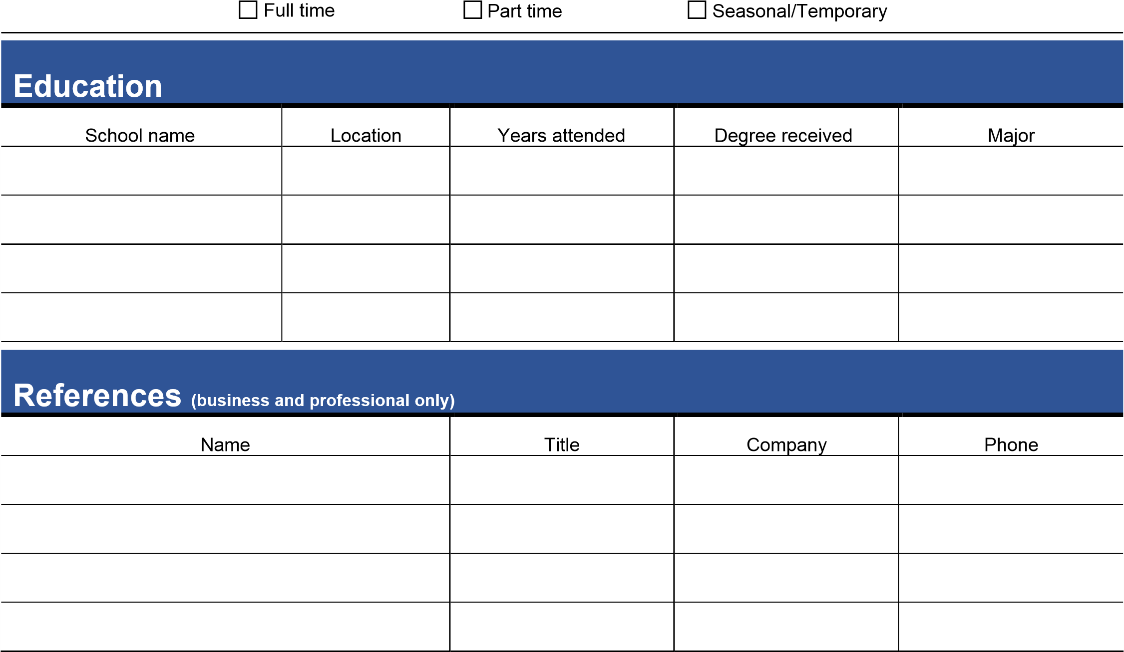
Employment History
Employer (1) | Job title |  | Dates employed
Work phone | Starting pay rate |  | Ending pay rate
Address | City | State | Zip
Employer (2) | Job title |  | Dates employed
Work phone | Starting pay rate |  | Ending pay rate
Address | City | State | Zip
Employer (3) | Job title |  | Dates employed
Work phone | Starting pay rate |  | Ending pay rate
Address | City | State | Zip
Signature Disclaimer
I certify that my answers are true and complete to the best of my knowledge.
If this application leads to employment, I understand that false or misleading information in my application or interview may result in my employment being terminated.
Date | Signature

